**Accuracy Comparison using different Kernels over 5 epochs(meaning over 5 time run over data)**

|  |  |
| --- | --- |
| Linear | o |
| RBF | o |
|  |  |
|  |  |
|  |  |

**Effect of applying HOG on Image of Digit**

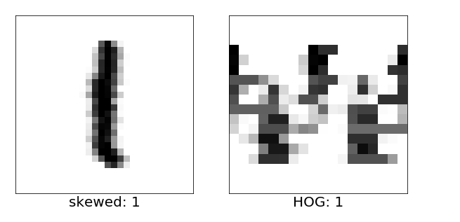

Effect of Increasing Value of C Parameter on Accuracy(Hyper parameter Tuning)

